Task No & Title: Unit 8 | Unit Descriptor Unit Descriptor This unit covers creating and using simple spreadsheets and charts through the use of spreadsheet software.
Title: | BSBCMN214A Create and use simple spreadsheets
Suitable for Classes: | Certificate II Business
Area: | Technology & Enterprise
Teacher: | Mr Peter Faulks
Timeline | 1 Lesson
Date Due: | Today
Task Brief: | Create a spreadsheet for your soccer team MXL021

Files Required

Items highlighted in yellow are tasks for you to complete
Items Blue are help tips

Unit | Number | Title | Study Time
1 | BSBCMN201A | Work effectively in a business environment | 20
2 | BSBCMN202A | Organize and complete daily work activities | 15
3 | BSBCMN203A | Communicate in the workplace | 30
4 | BSBCMN204A | Work effectively with others | 20
5 | BSBCMN205A | Use business technology | 30
6 | BSBCMN211A | Participate in workplace safety procedures | 15
7 | BSBCMN213A | Produce simple word processed documents | 40
8 | BSBCMN214A | Create and use simple spreadsheets | 20
9 | BSBCMN108A | Develop keyboard skills | 40
10 | BSBCMN107A | Operate a Personal Computer | 20
11 | ICAITU013C | Integrate Commercial computer packages | 30
12 | ICAITU012C | Design Organizational Documents using computer | 50
 |  | TOTAL

Convert the following into two colums and change the font

Make the document appear more professionally presented – you could correct the tabs

Save the work

Soccer Team Account Exersize Spreadsheet MX021

Open MXL021 Exersize 01 Soccer Q.xls

INSTRUCTIONS
Using Text in Excel
You simply type in the cell that you wish to add text to Rows or Columns
You format the text size and font and Bold, Italic or add a colour
You can format the cell shading or colour
Change the font type or colour in the sample shown here
Add your name to the bottom row
FULL NAME
If you want to show both names in one cell use the & (add) feature
Joining Names :- The Cell plus & Inverted commas " " (to create a gap) plus (&) next cell
C12&" "&D12 (add an = sign before the formula)
You may need to widen the cells to show the names in full
try this in all the names shown
PARTIAL NAME
If you only wanted to show a portion of the names you can use this method
LEFT(O2,3)&LEFT(P2,4) (add an = sign before the formula)
Reference to the cell followed by a coma and the number of characters you wish to see
Change the number of characters for your name to show 5 characters
Note You can autofill the formula down because RELATIVE CELLS will change automatically
Using Text for Dates
You can use the text format to show days, months in date formats
use the TEXT formula:- Reference Cell, "ddd) shows 3 characters days (mmm :- Months)
TEXT(B32, "ddd") (add an = sign before the formula)
add the day then add the month in the cells shaown
change the cells to show full day or full month (add more d's or m's)
Add names to the list by linking cells (=) to the full name cells above
Complete the above then
Now start Exersize 1

Do this on the spreadsheet

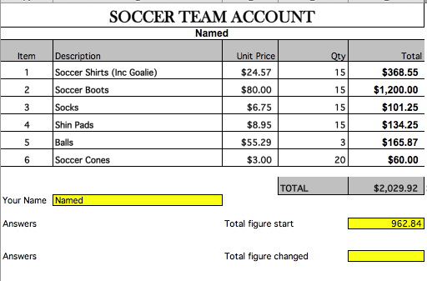

- Enter text and numbers on the Exersize 1 worksheet
- Enter the formula in E4 to calculate total, this will be = Unit price * Qty show the formula without = next to each row for extra marks
- Use the Autofill feature to copy the formula through E4 down to E9
- Add the name of your team to cell A2 (center this (make your own team name)
- Merge cells SOCCER TEAM ACCOUNT A1 through E1
- Take note of the total figure and enter this where shown
- Change the price of socks to $8.00 (just enter an 8)
- Note the new total where shown
- Add your name where shown
- Save the file as MXL021 Exersize 01 your surname.xls to your file


Student Name: | Date submitted:
I declare this evidence to have been produced by me the undersigned.

Candidate’s signature:
Title of Portfolio evidence presented Enter title here
BSBCMN214A Create and use simple spreadsheets Section 08:???
□ Outcomes from learning programs (including self-learning and online learning)
□ Assessment feedback (from a trainer or assessor)
□ Observation checklists (from a workplace supervisor or assessor)
□ Written statements or references (including workplace supervisors, community leaders)
□ Job descriptions
□ Work journal
□ Work samples
□ Finished products
□ Product descriptions or specifications (supporting the product samples included)
□ Statutory declarations
□ List others (or delete any from above not provided)
- All work submitted to be word processed and spell checked.
- There must be at least two samples of evidence for each
Element within the Unit of Competency. This is sample 1 / 2
- All work submitted must be of a high quality and meet the
requirements of the Unit of Competency.
Other evidence (List each piece):
Assessor to complete
Evidence is Valid Sufficient Authentic Current
□ □ □ □

Assessor signature: _________________________________Date: _____________
Peter Faulks, BA Soc Sci, Grad Dip Ed, Cert IV AWT
Certificate II in Business assessor/teacher
Assessor to complete

Student is declared Competent Not Yet Competent
□ □

Keep a copy of this report with your file for evidence

